Trade stream Architecture

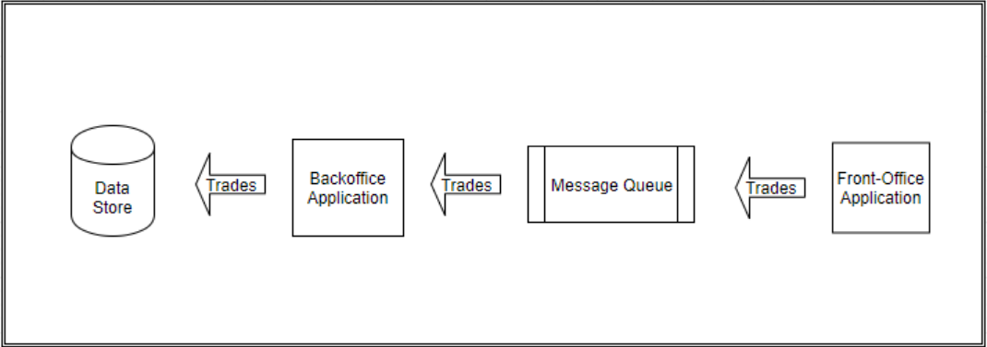

# Front Office

Web application with a single **POST** endpoint **/trade**

Here is how a Post body request looks like

{

    "tradeId": "T1",

    "version": 1,

    "counterPartyId": "CP-1",

    "bookId": "B1",

    "maturityDate": "01/01/2021",

    "createdDate": "03/02/2021",

    "expired": "N"

}

It is also a **Kafka Producer**, after validation, the object is send to the queue on topic **trade-topic**

# Message Queue (Kafka)

A Kafka instance is running on port **localhost:9092** ready to receive a message on topice **trade-topic**

# Back Office

This is a **Kafka Consumer** application built with Spring Boot. It listen on Topic **trade-topic** and save it to the Database

# Database

For persistence i choose an **embedded H2 database** connected to the Back Office Application. There is also a browser console on **localhost:8082/h2-console**